Design: EOD Report Transmission to OPRA

Overview

Current processing
Most of the processing already exists as it was written for COF_MAIN session. Existing flow is explained under sequence diagram.

New requirement
CBOE needs to send report to COPP Adapter at end of day. Copp Adapter format the report and send it to OPRA. MarketDataSummaryService is used to gather the data. This service returns array of ClassSummaryStruct. Required array of OpraReportStruct for EOD report is created from this array of struct.
The OpraReportStruct for COPP includes following details which is already exist:
- productSymbol
- expirationMonth
- expirationYear
- strikePrice
- opraMonthCode
- opraPriceCode
- sessionInd
- totalVolume
- openPrice
- highPrice
- lowPrice
- lastPrice
- openInterest
- netChangeInd
- netChange
- bidPrice
- askPrice
- underlyingStockPrice

After sending the summary data, in the end, CD needs to send the total all series volume and total all open Interest data.

This report is transmitted every day by 16:00:00 by Operations team, after closing all products.

Scope
Scope of this design document is limited to formatting & sending array of OpraReportStruct to COPP. In case of W_MAIN we need to pass the total volume and total open interest of all series.

Assumptions
- Existing script “createAndSendEODReport” will create and send the EOD report to OPRA. If user tries to run script “createEODReport” or “sendEODReport”, then message should be displayed to user such as “For OPRA, Use createAndSendEODReport”.
- Both scripts, “createAndSendEODReport” and “coppAdmin startSummary”, will create and send the EOD Report to OPRA.
- There is no need to save report; COPP Queue implementation will take care of it.
- The sorting of data will be done at COPP before sending the report to OPRA.

Implementation

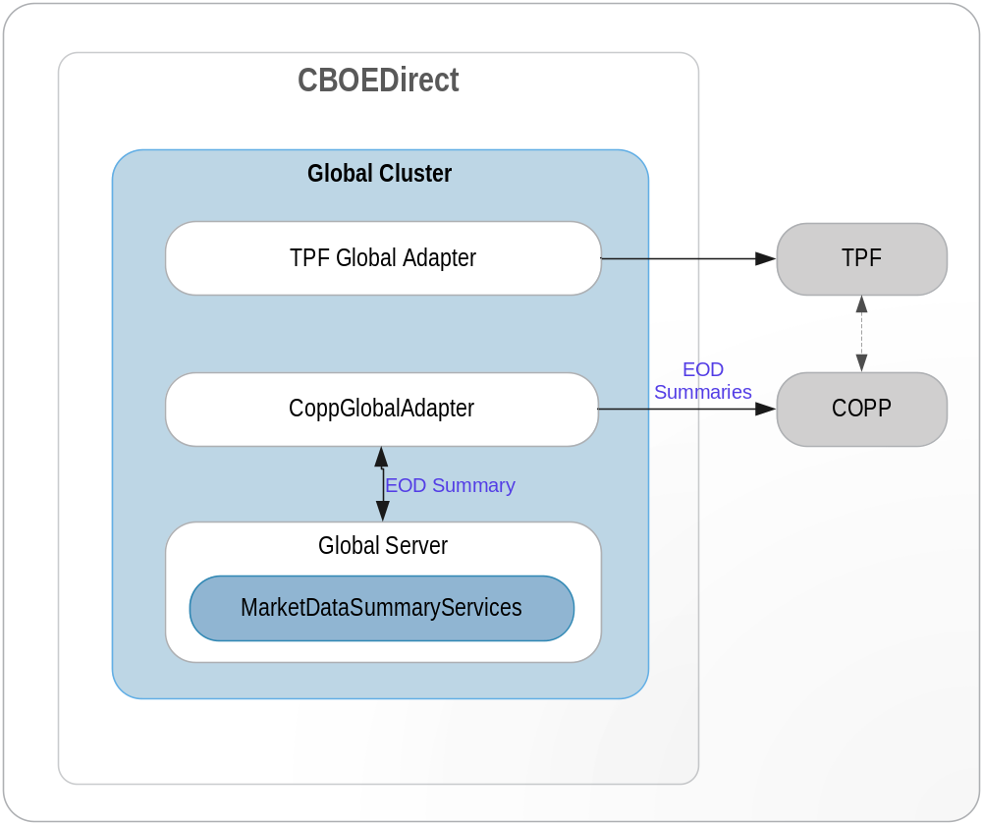
1. End of Day Report for OPRA Flow

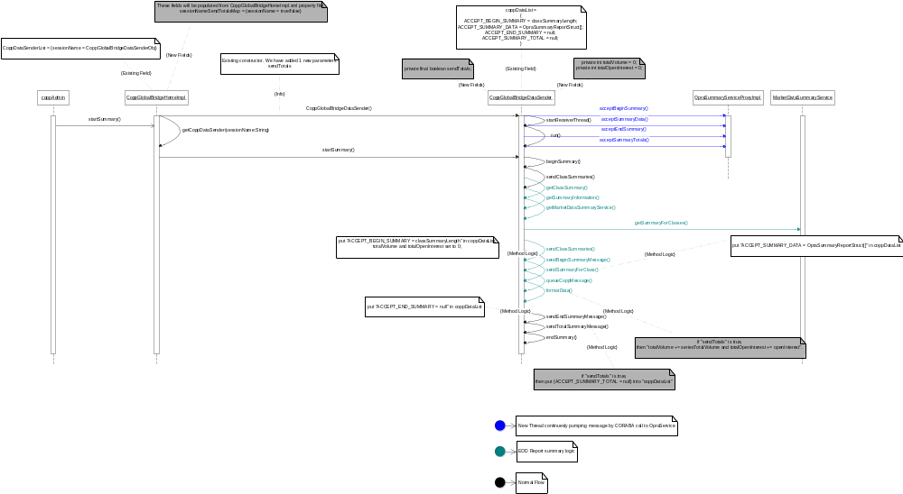
- MarketDataReportService calls the find() method of MarketDataReportGeneratorServiceHome which returns the object of MarketDataReportGeneratorService. It registers this object with the ar command ‘createReport’ in the initialize method.
- MarketDataReportService calls the find() method of CoppGlobalBridgeHome. This will be used by MarketDataReportGeneratorService to start the transmission of EOD report to OPRA.
- Operations team executes createAndSendEODReport shell script that takes the following parameters
  - Report Type
  - Session Name – W_MAIN (e.g.)
Report Type | Parameter 1 (Report Type) Value | Parameter 2 (Session Name) Value
HALF_HOURLY_OPRA | 1 | W_MAIN
HALF_HOURLY_NEWS_WIRE | 2 | W_MAIN
END_OF_DAY_OPRA | 3 | W_MAIN
END_OF_DAY_NEWS_WIRE | 4 | W_MAIN
HVOL | 5 | W_MAIN
HALF_HOURLY_NW_OPRA | 12 | W_MAIN
HALF_HOURLY_OPRA_HVOL | 15 | W_MAIN
EOD_NW_OPRA | 34 | W_MAIN
HALF HOURLY_NW_OPRA_HVOL | 125 | W_MAIN

- This shell script calls the ar command 'createReport’ which calls ‘createReport’ method of MarketDataReportGeneratorService.
- createReport method of MarketDataReportGeneratorService then calls the private method createEODOPRAReport.
- createEODOPRAReport method will call “startSummary(sessionName)”method of “CoppGlobalBridgeHome”.
- One new instance variables “sessionNameSendTotalsVol” and “sessnNTotd in “CoppGlobalBridgeHomeImpl”Theise maps will be get populated from “CoppGlobaBrigeHomImpl.xml”.
- “startSummary(sessionName)” will create new instance of “CoppGlobalBridgeDataSender” for the given session after passing extra 1 parametersto existing constructor.
- Three new instance variables added in “CoppGlobalBridgeDataSender”, two integer variables (“allSlVolume” and “allSeriesTtotaest”) will be used for total volume and total open interest calculations and twoone Boolean variablessendAllSeriesTotalsVolue” and “riesOpenIntereseis usedheck d for sending total summay d.
- Both integer variables will be set to zero, when “sendBeginSummaryMessage()” method of “CoppGlobalBridgeDataSender” is called.
- In “formatData()” method, these two instance variables are updated.
- After call to “sendendOfSummary()” method , we will give call to new method “sendTotalSummaryMessage()” which will send values of these instance variables to “OpraSummaryService”.

2. IDL Changes
Method in bold is new.
Interface OpraSummaryService {
void acceptBeginSummary(String id, String sessionName, int totalClasses, char sessionIndicator)
void acceptSummaryData(String id, String sessionName, OpraSummaryReportStruct[] block)
void acceptTotals(String id, String sessionName, int totalVolume, int totalOpenInterest);
void acceptEndSummary(String id, String sessionName, char sessionIndicator)
void acceptEndOfReporting(String id, String sessionName, String message, char sessionIndicator)
void acceptTextMessage(String id, String sessionName, String message, char sessionIndicator)
void acceptSummaryTotals( in CoppBridgeId id, in string sessionName,
in long totalVolume,
in long totalOpenInterest)
raises(
exceptions::SystemException,
exceptions::CommunicationException,
exceptions::AuthorizationException
);
}

3. Interfaces and Classes
Interfaces:
- com.cboe.interfaces.businessServices.MarketDataReportGeneratorServiceHome.java : Add the following methods
- find
- create

- com.cboe.interfaces.businessServices.MarketDataReportGeneratorService.java : Add the following methods
- String createReport(String reportType, String sessionName)

Classes:
- com.cboe.businessServices.marketDataReportService.MarketDataReportGeneratorServiceHomeImpl.java
- find: returns the MarketDataReportGeneratorService object
- create: creates and returns the MarketDataReportGeneratorService object
- goSlave
- goMaster
- initialize: Loads the properties from the MarketDataReportGeneratorService.xml file
- com.cboe.businessServices.MarketDataReportGeneratorServiceImpl.java : Add the following methods
void createEODOPRAReport ()
This method calls the CoppGlobalBridgeHome to create ans send the EOD report to OPRA.
- com.cboe.externalIntegrationServices.coppBridge.CoppGlobalBridgeHomeImpl
New field will be added which will be populated from CoppGlobalBridgeHomeImpl.xml property file in initializer() method.
  - sessionNameTotalsMap => {sessionName = true/false}

- com.cboe.externalIntegrationServices.coppBridge.CoppGlobalBridgeDataSender
Three New fields will be added. Constructor will take 1 new Boolean argument to initialize Boolean field.beginSummary() will set these 2 integer fields to 0.
  - private final boolean sendTotals;

  - private int totalVolume = 0;
  - private int totalOpenInterest = 0;
- com.cboe.proxy.externalIntegrationServices.OpraSummaryServiceProxyImpl
  - New method sendTotalSummaryMessage() will be added
- com.cboe.interfaces.businessServices.MarketDataSummaryService
  - Existing method getSummaryForClasses() used for getting data.

Logging
Informative messages will be logged at the beginning and end of each important method.

Exception Handling
All the exceptions will be propagated to the top level i.e. the method that is called from the ar command. This method will then log the exceptions (Log.exception) and return appropriate status from the method.

Scripts(1)

createAndSendEODReport
This is a wrapper script for the admin request to createReport which will call the CoppGlobalBridgeHome create and send EOD report to OPRA.

In case of OPRA, if user tries to run script “createEODReport” or “sendEODReport”, then message will be displayed to user such as “For OPRA, Use createAndSendEODReport”.

This script will first check all products closed, if closed then it calls the ar command “createAndSendEODReport”

Database(.5)
None

SetContext(.125)
None

XML/DTD(.5)

server\properties\xml\CoppGlobalBridgeHome.xml
- server\properties\dtd\CoppGlobalBridgeHome.dtd
sendTotals tag will be added under parent tag remoteServiceRoutenameConfigurationProperties. This tag will take value “true” or “false”.
New tag "sendReport” added which will take value “true” or “false”.

Homes/Services(2)
MarketDataReportServiceHome.java
MarketDataReportServiceImpl.java
MarketDataReportGeneratorServiceHome.java
MarketDataReportGeneratorService.java
com.cboe.externalIntegrationServices.coppBridge.CoppGlobalBridgeHomeImpl;
com.cboe.externalIntegrationServices.coppBridge.CoppGlobalBridgeDataSender;
com.cboe.proxy.externalIntegrationServices.OpraSummaryServiceProxyImpl;
com.cboe.interfaces.businessServices.MarketDataSummaryService;

ImplPlan(.5)
- In server\properties\xml\CoppGlobalBridgeHome.xml, set value for “sendTotals” for the session to “true” or “false”. “true” will cause Total Summary will be sent to COPP. “false” will cause total Summary will not be sent to COPP.
- In server\properties\xml\CoppGlobalBridgeHome.xml, set value for “sendReport” for the session to “true” or “false”. “false” will cause HH Report generation and log it. But, report will not be sent to COPP. “true” will cause HH Report generation, log and will be sent to COPP.

PerformanceTestingProcedure(1)
None

TestingProcedure(1)
None

OperatorProcedure(.5)
None

Fallback/Failover
None

GUI Design
None.
Comments:
- Add common variable in setContext.main which will used to decide whether ar command for Report needs to be executed or not?
- Before executing ar commands, we should check for all products closed or not. If not closed, display message such as “All Products for the session <<session name>> need to be closed for creating EOD Report to OPRA”

Modified Files:
